**DOCKER SWAM MODE PLAYGROUND**

**CREATE SWAM CLUSTER**

Initialize

docker swarm init

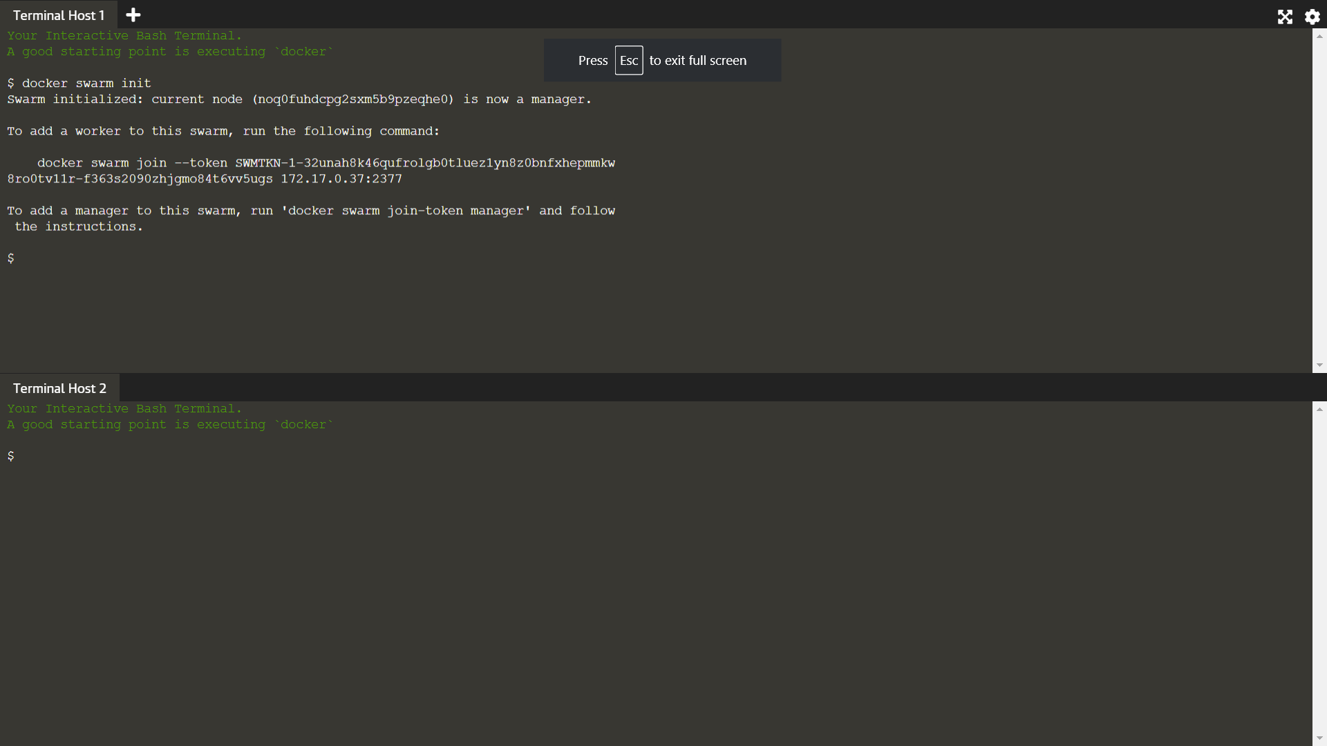

Join

token=$(ssh -o StrictHostKeyChecking=no 172.17.0.37 "docker swarm join-token -q worker") && echo $token

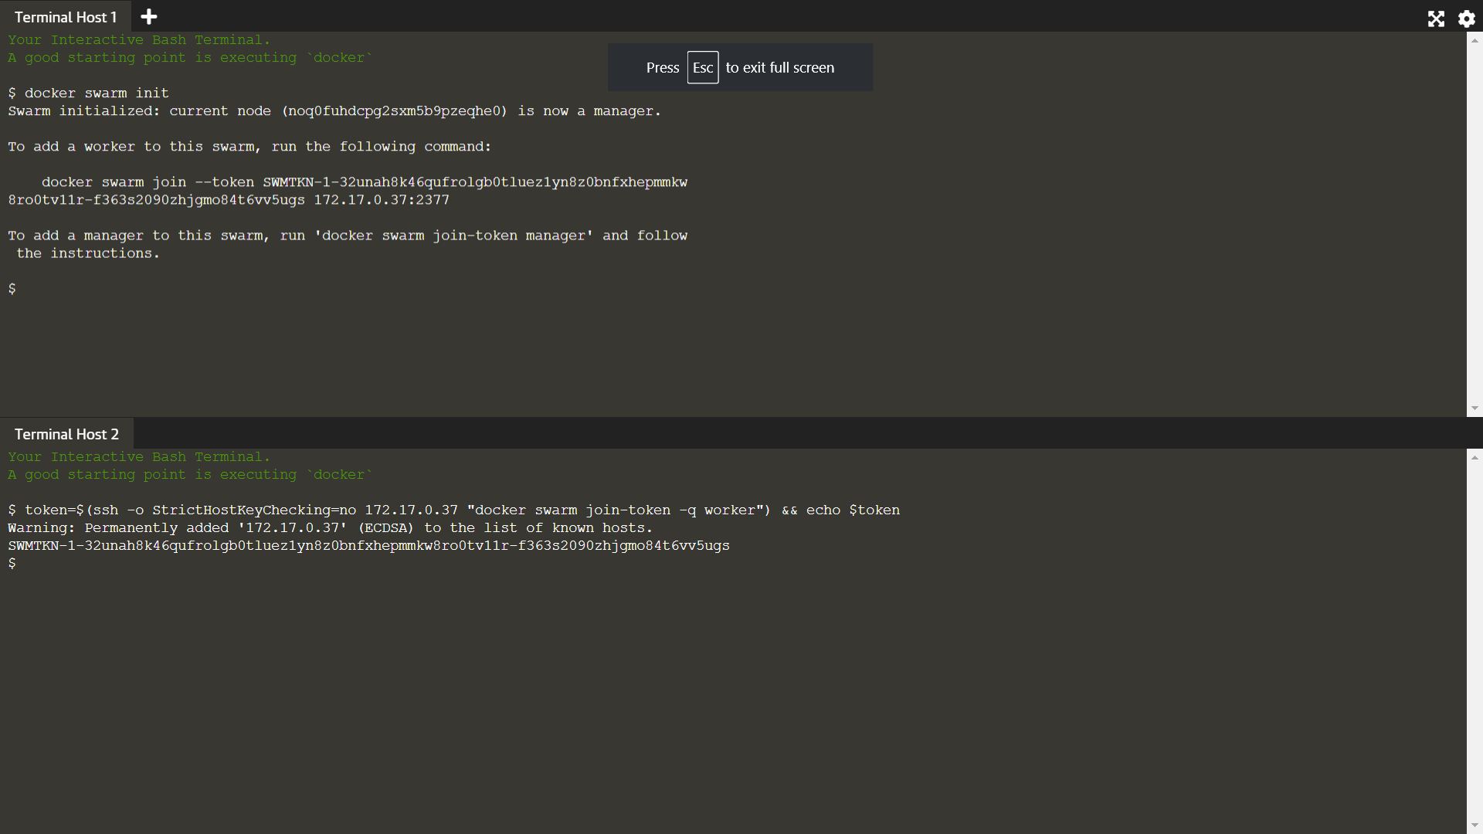

docker swarm join 172.17.0.37:2377 --token $token

Create overlay network

docker network create -d overlay Skynet

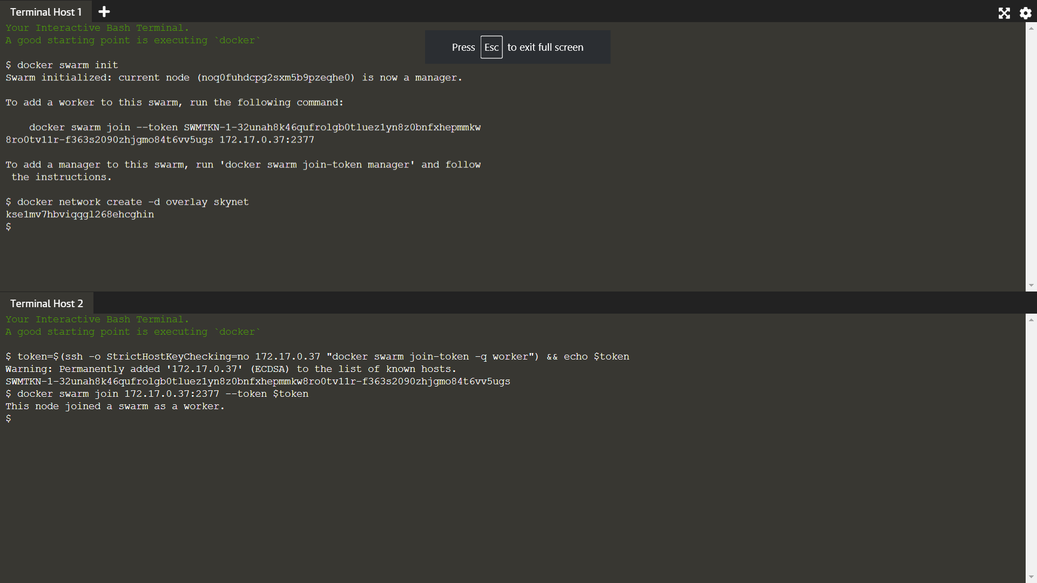ss